**Steps to Dockerize Flask App**

1. Download and run docker toolkit exe file from <https://github.com/docker/toolbox/releases> and if the downloaded version doesn’t support in your machine, try with other lower or higher versions of toolkit.
2. After successful installation, go to start and click on Docker QuickStart Terminal. Refer image (highlighted in red)

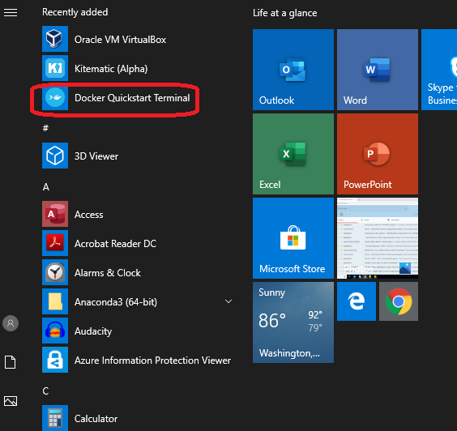

1. This will open a docker command prompt and will take some time to load properly. There will be Docker image at first and machine IP which will be used to access flask app. Refer image (highlighted in red)

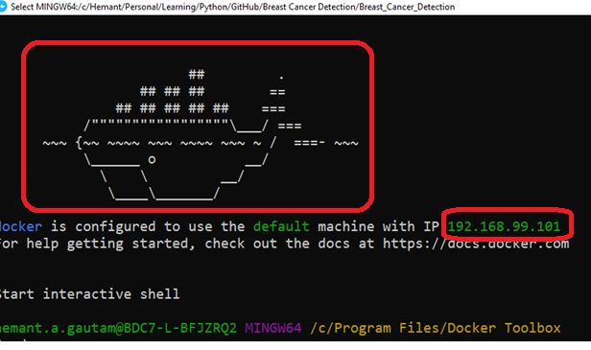

1. Next step is to navigate to the project root folderin docker cmd where Dockerfile is present. Refer image (highlighted in red)

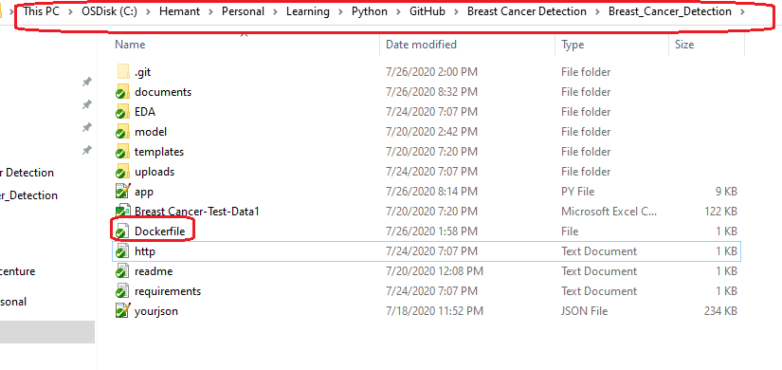

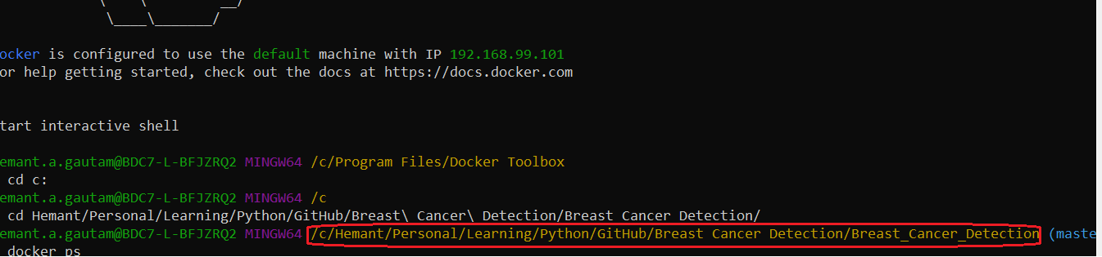

1. Creating docker file is important to dockerize flask app. And to create Dockerfile file, these are the commands should be mentioned. Refer image (highlighted in red

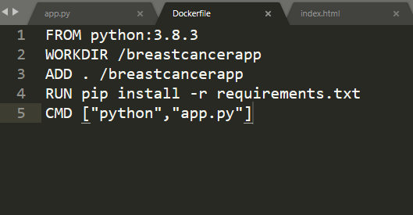

1. Command to check if any existing docker image is running or not. There is no image showing in the below image –



1. Command to create image, this will download python version mentioned in Dockerfile and all the other dependent packages(from requirements.txt):

docker image build -t breastcancer-image .

1. Command to check if image is created successfully:

docker image ls

1. Finally to run the created image locally, run this command –

docker run -p 5001:5000 -d breastcancer-image

1. To access the dockerize flask app, use the IP address which shown at the time of opening docker toolkit along with port 5001, and paste that in browser -

<http://192.168.99.101:5001/>

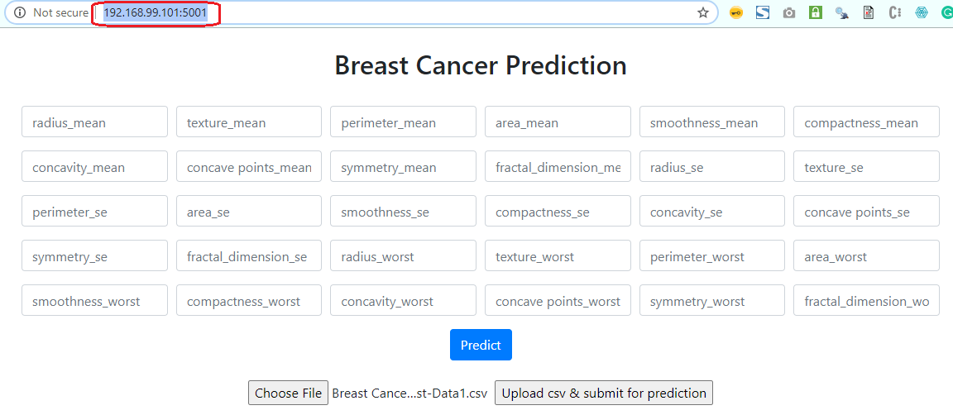

1. Dockerization is completed.

Reference Link –

<https://medium.com/@tasnuva2606/dockerize-flask-app-4998a378a6aa>